***ATTENDANCE MANAGEMENT SOFTWARE***

***Developed by:***

***Rakesh Kumar T***

***ABOUT***

This software offers two accesses: one for the user & the other for the admin. Both of the users have their own unique login ID and password to access their features. The software offers 6 User features for user & 6 features for admin.

The features for the **USER** are listed below:

1. View Time Table
2. Update Attendance
3. View Attendance *(Filters: Roll No, Specific Date, From-To, Till Date)*
4. Update Time-Table
5. Add Student
6. Prediction

The features for the **ADMIN** are listed below:

1. Update Subjects
2. Change Semester
3. Change Year
4. Update Information
5. Update Attendance
6. Previous Attendance

This software was initially created for Valliammai Engineering College (SRM GROUP) for reducing the manual efforts & time consumption of the programmer/DEO, and also to provide a good user experience in maintaining the records.

*Though the software was created for Valliammai Engineering College, it’s flexible and can be modified for all other colleges.*

*USER*

*FEATURES*

**LOGIN PAGE**

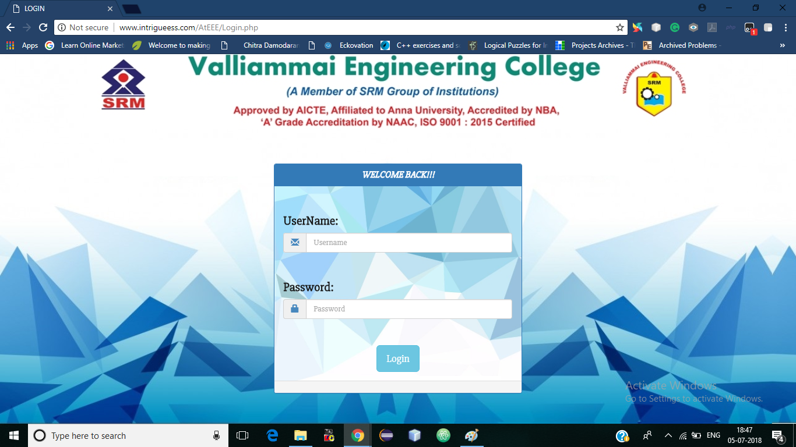 This is the login page common for both user & the admin.

**VIEW TIME TABLE**

The user will be redirected to this page after his successful login (USER/DEO)

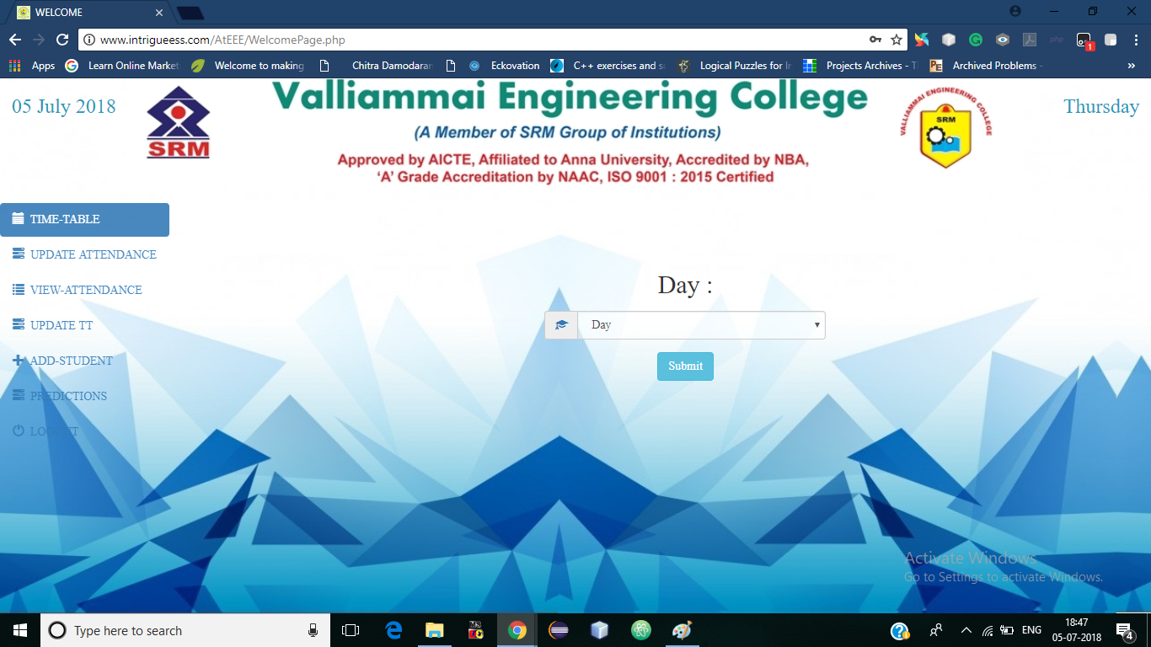

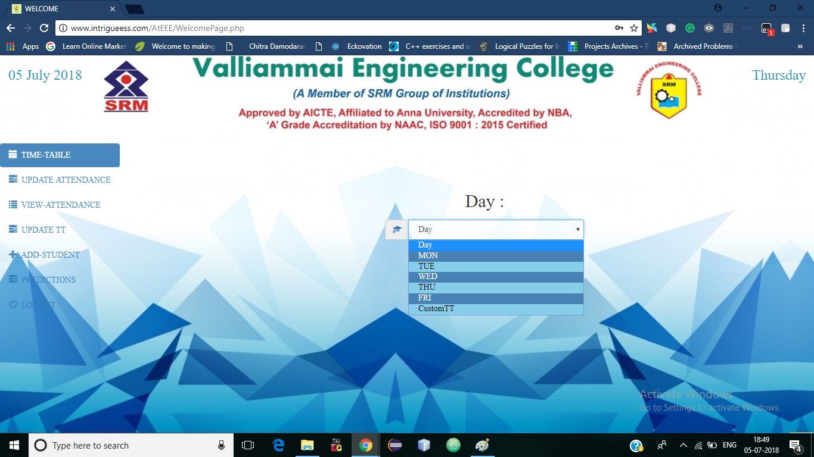In this part, the user will be able to view the time table for the particular day for all the classes. The select option is as mentioned.

Sometimes, there may be a temporary time table. To enable that option, the user must update the custom timetable & select the **CustomTT**.

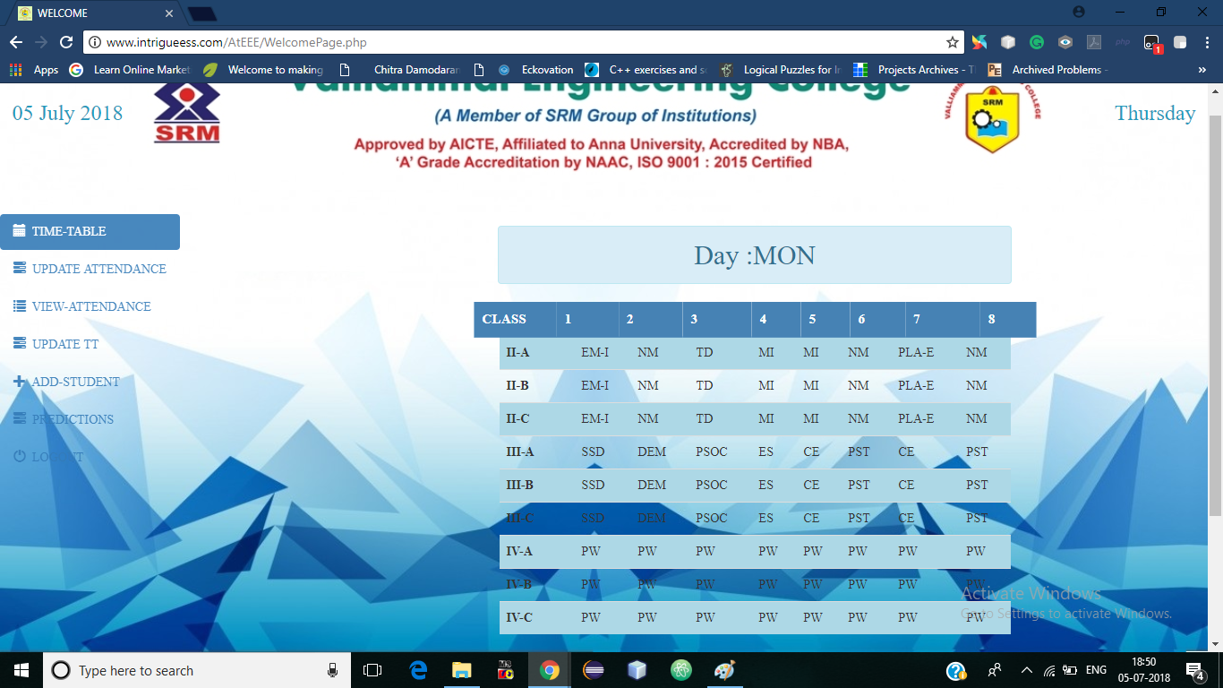Below given is the Time Table fetched for Monday for all the 3 Years & Sec

Before moving to the next step, the user must make sure that they have selected the current day as the total number of hours for updating the attendance will be automatically calculated based on the day selected in this page.

**UPDATE ATTENDACE**

In this page, the user will be able to update the attendance for all students based on their Year & Sec.

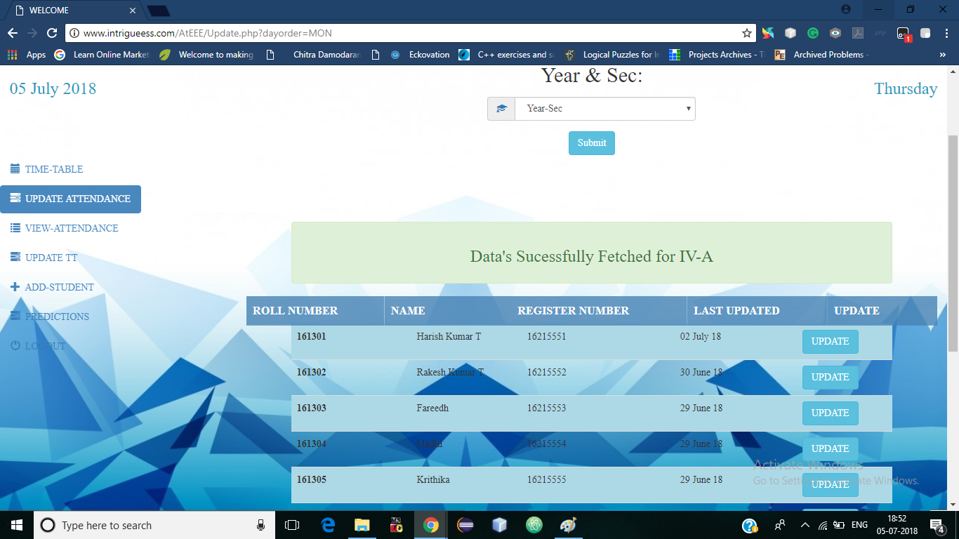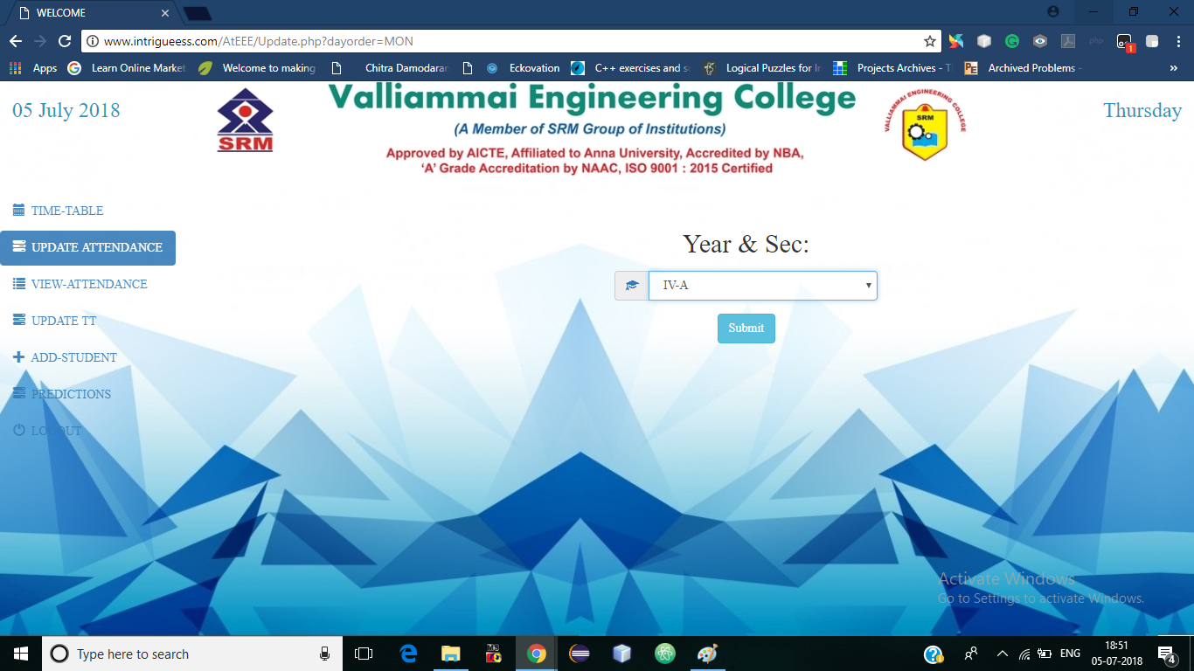Below is the result after the selection of Year& Sec.

Once we click the Update Button we’ll be redirected to the next page to update the attendance for the particular student.

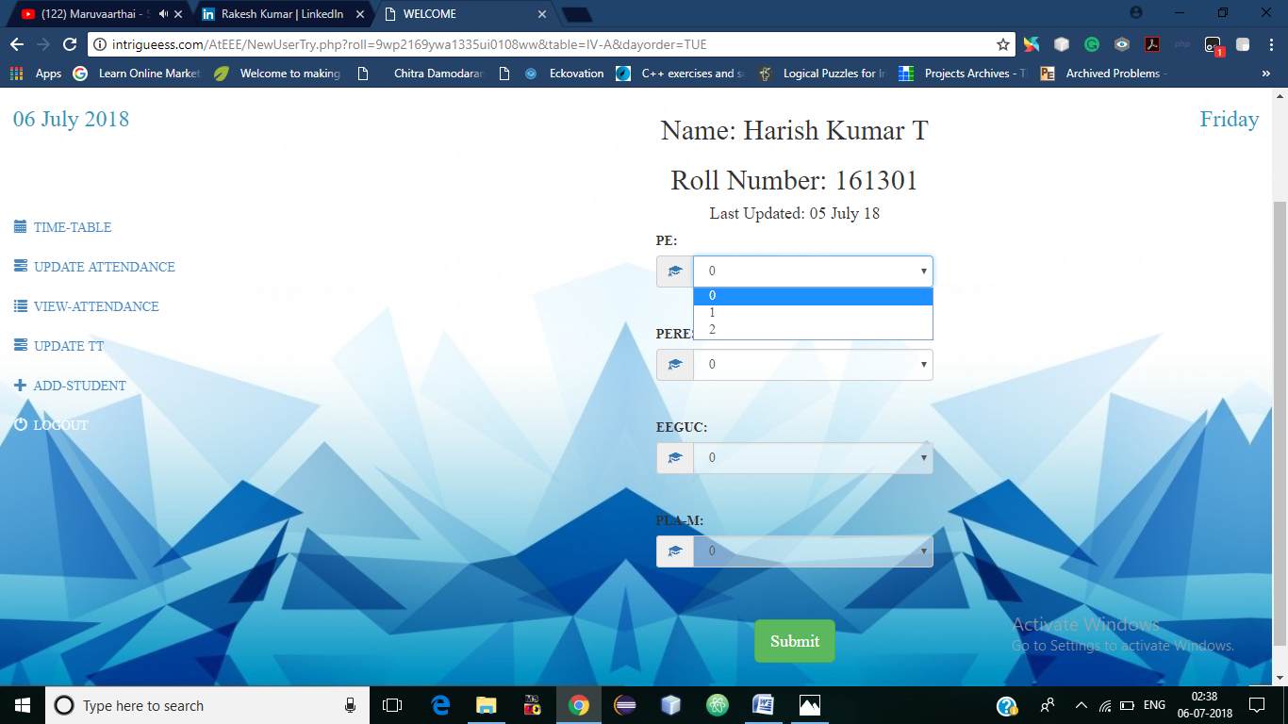The user will be provided with the subjects with their max number of hour.

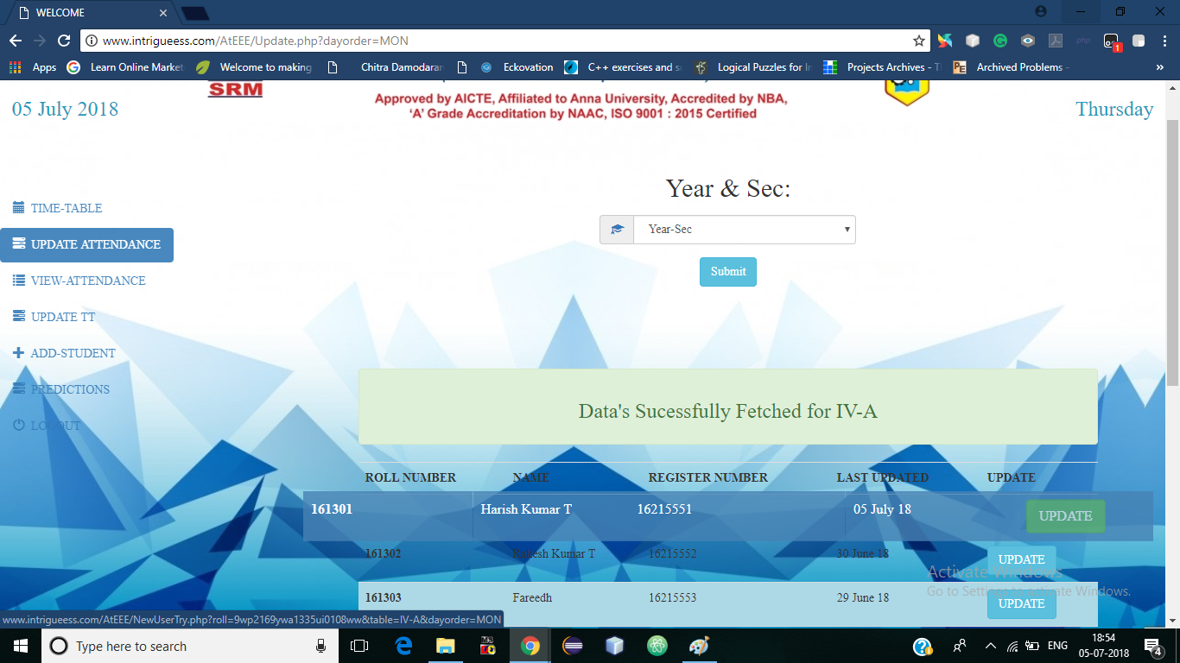After Submitting the record, the last updated date will be changed to the current date & the Update button will be disabled as we should not update the attendance more than once

In case of wrong entry, the issue must be reported to the admin & correct the number of hours which is under admin control.

**VIEW ATTENDANCE**

This page allows the user to view attendance with various filters as given below

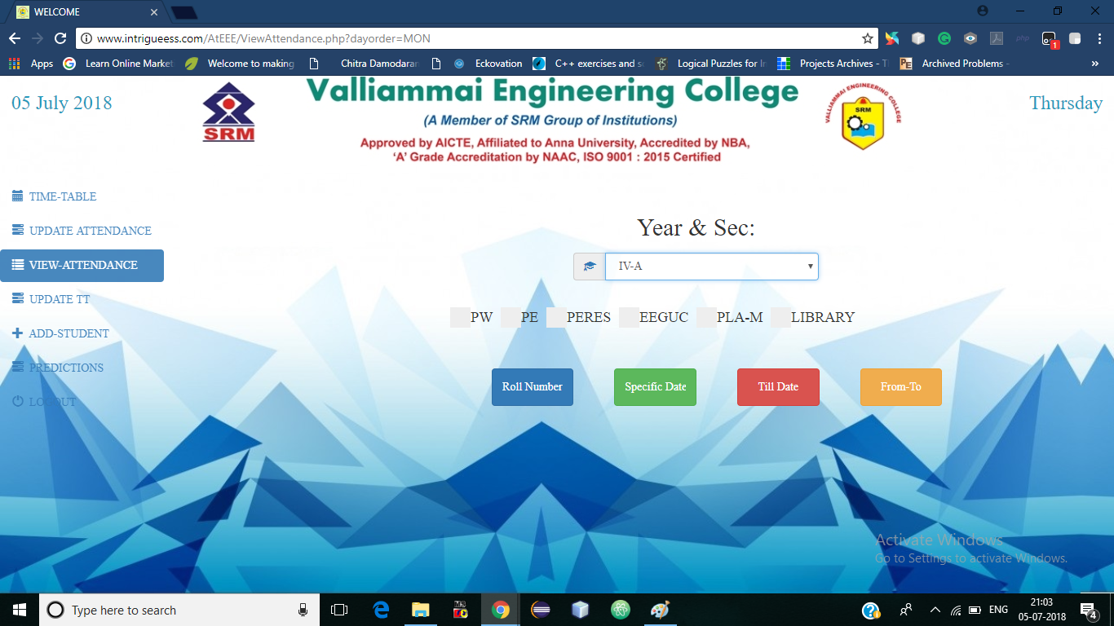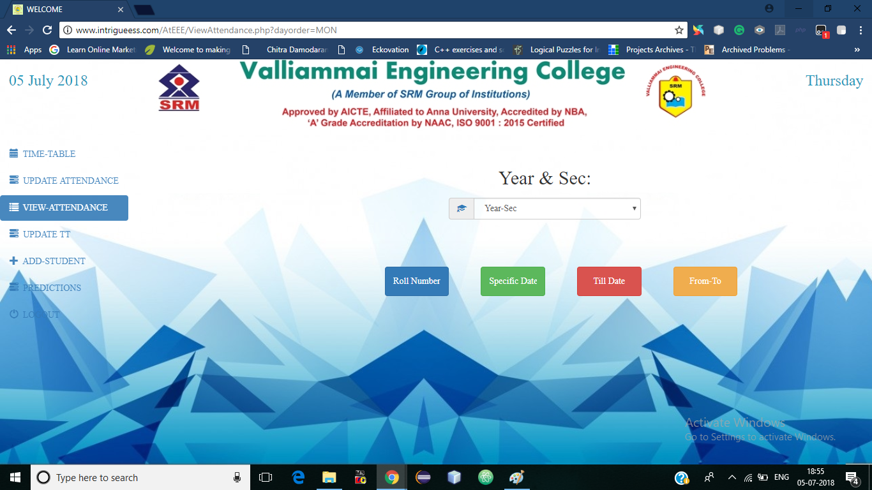The below given image is after the selection of class which are listed to filter the subjects that are not necessary for calculating the overall % or which are not to be displayed. If none of the checkbox is checked, all the subjects will be displayed with overall % including all subjects.

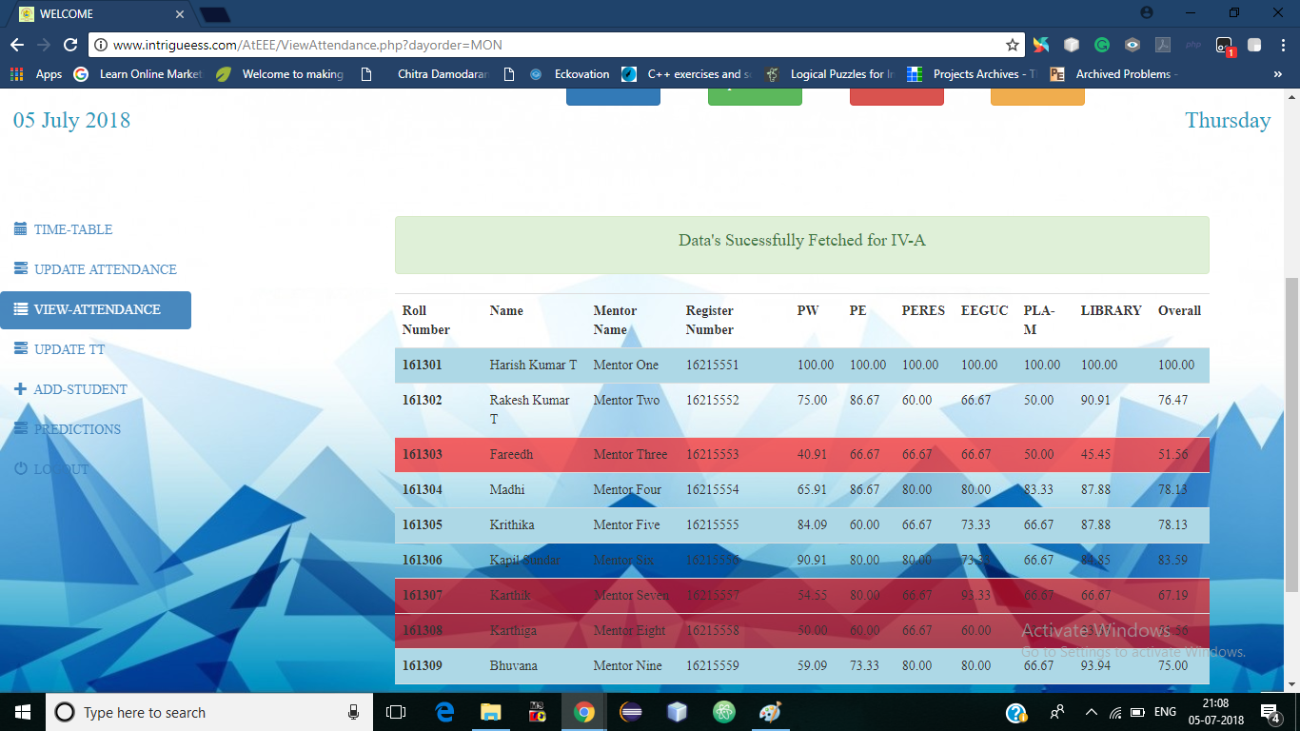The below given image is after the selection of **TILL DATE** filters (with no checkbox).

The red colour data rows are the students with less than 75% attendance.

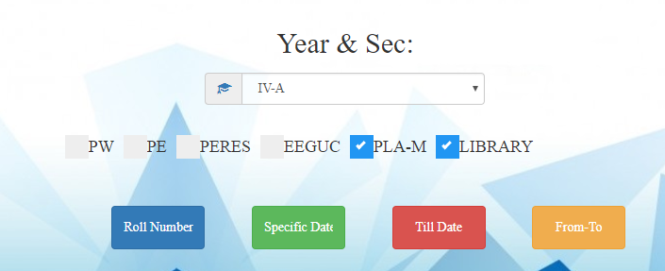 The below given image is after selecting the **TILL DATE** filter with **PLA-M & LIBRARY** checked (i.e., excluding the two subjects)

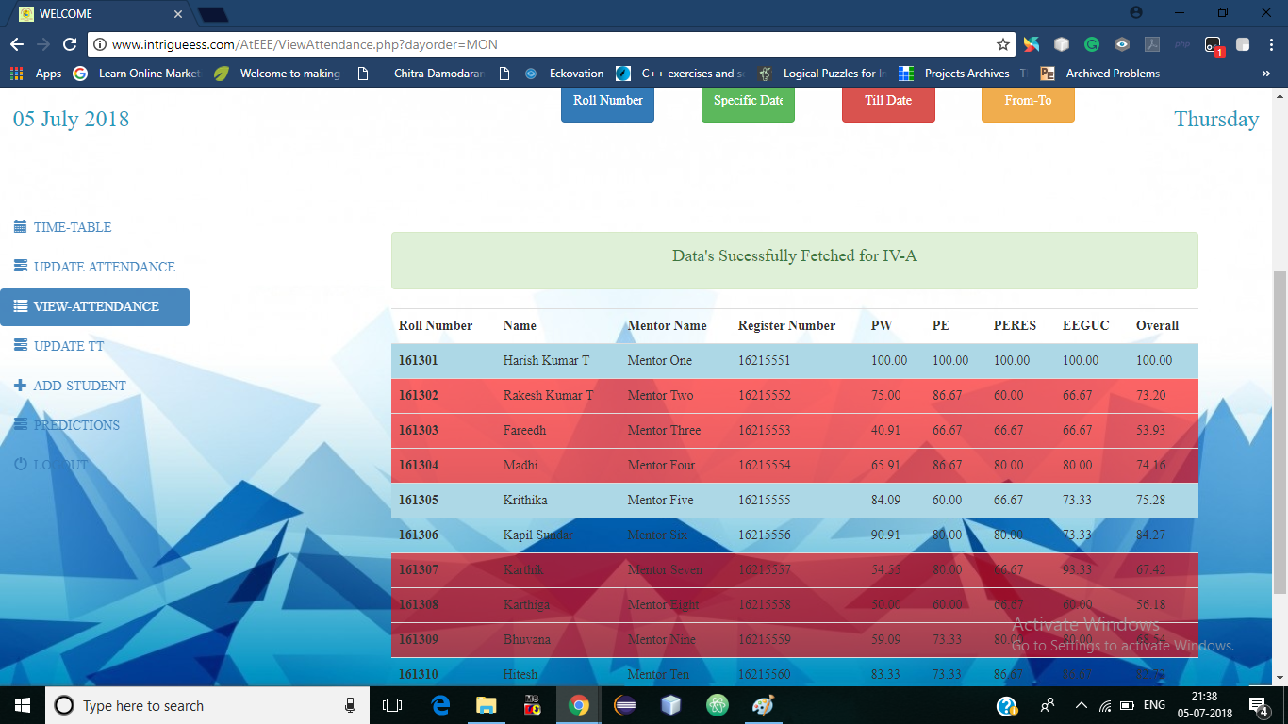

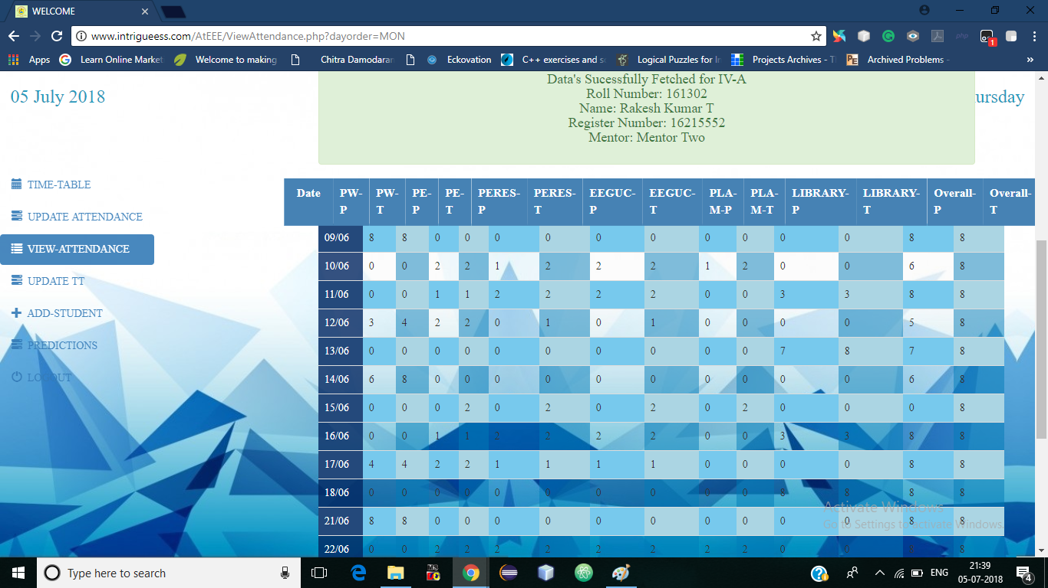 The below given is the image for **specific Roll Number**. At times there may be a situation where an individual student comes for his/her own verification of attendance, we could filter only his attendance record by entering their roll Number. This will display their presence day by day with total number of hours attended by a student with total number of hours of the particular subject on the day

 The below given is the input field to filter the data by **SPECIFIC DATE** for all the students which gives similar results to **TILL DATE**.

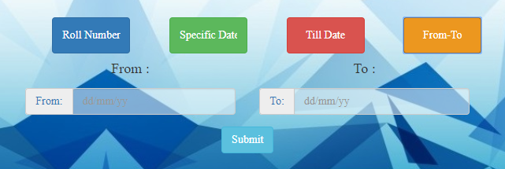The below given is the input field to filter the data by **FROM-TO** for all the students which gives similar results to **TILL DATE**.

**UPDATE TIME-TABLE**

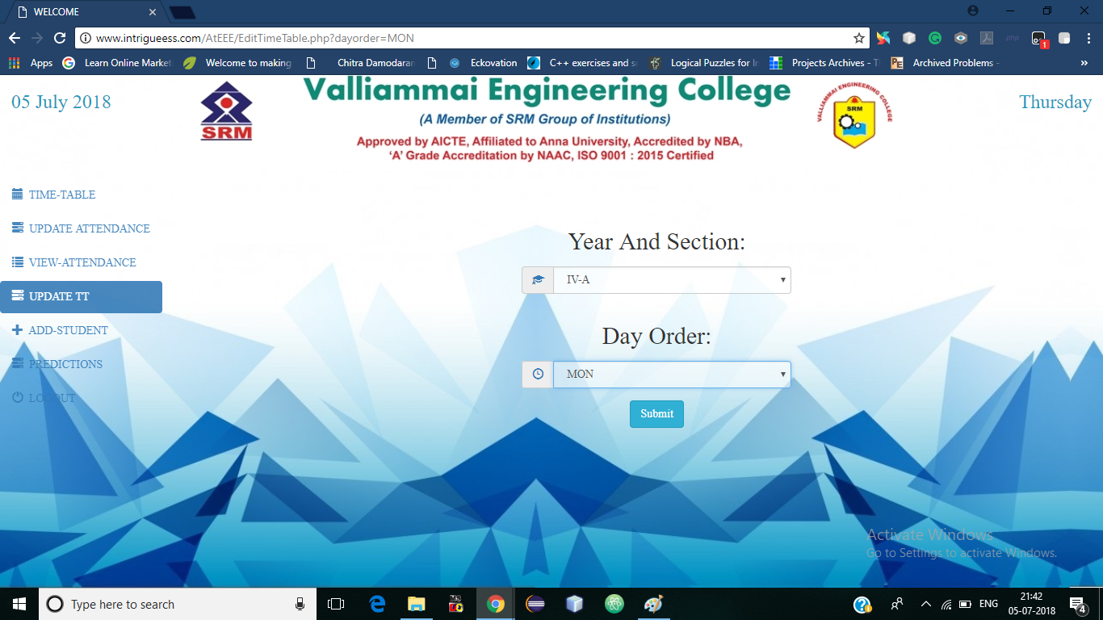In this page the user will be able to update/set the time table for the days. The user can also update the CUSTOMTT here which will reflect in the TIME TABLE page.

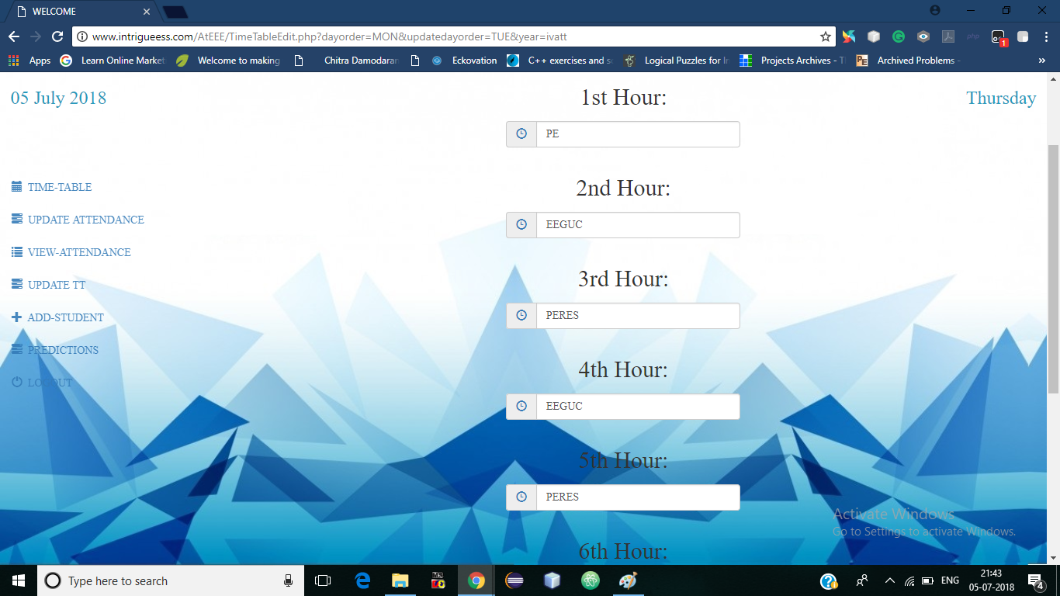

**ADD STUDENT**

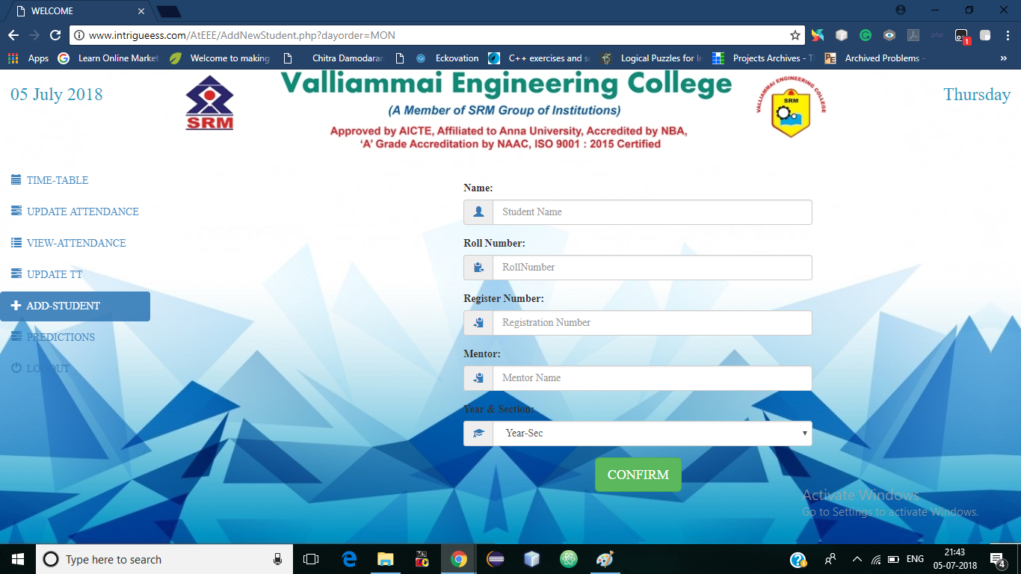In this page, the user will be able to enter the data of new student. This data is to be entered only at the time of admission & when there is an admission of a new student at the middle of the year.

**PREDICTIONS**

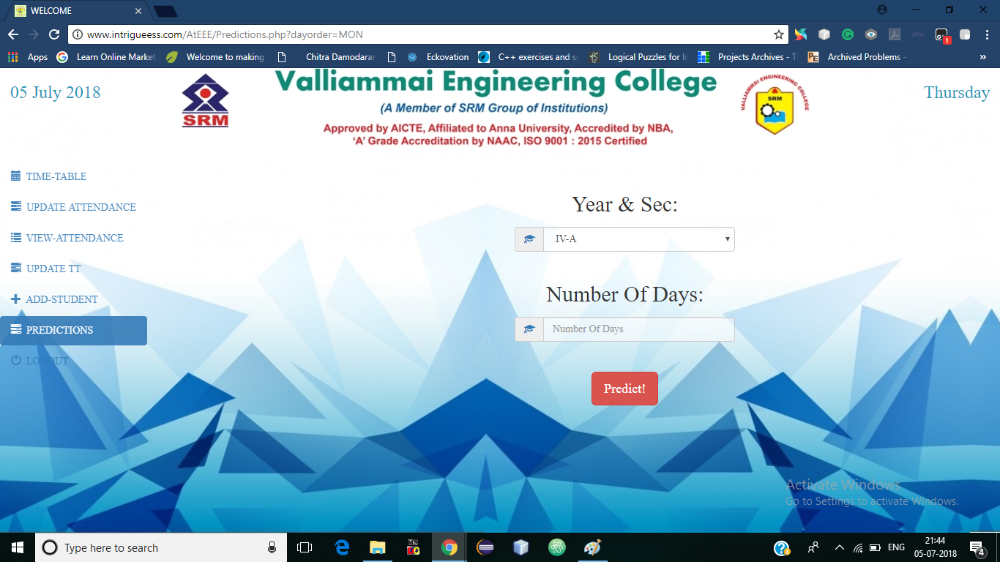This feature has two functionalities.

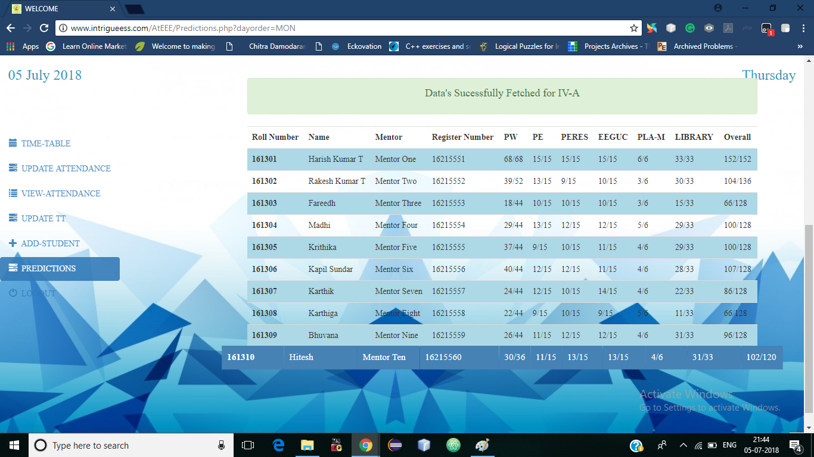When the class is entered without entering the number of days, this will display the total number of hours attended by the student & the total number of hours for individual Subjects & the overall Till Date.

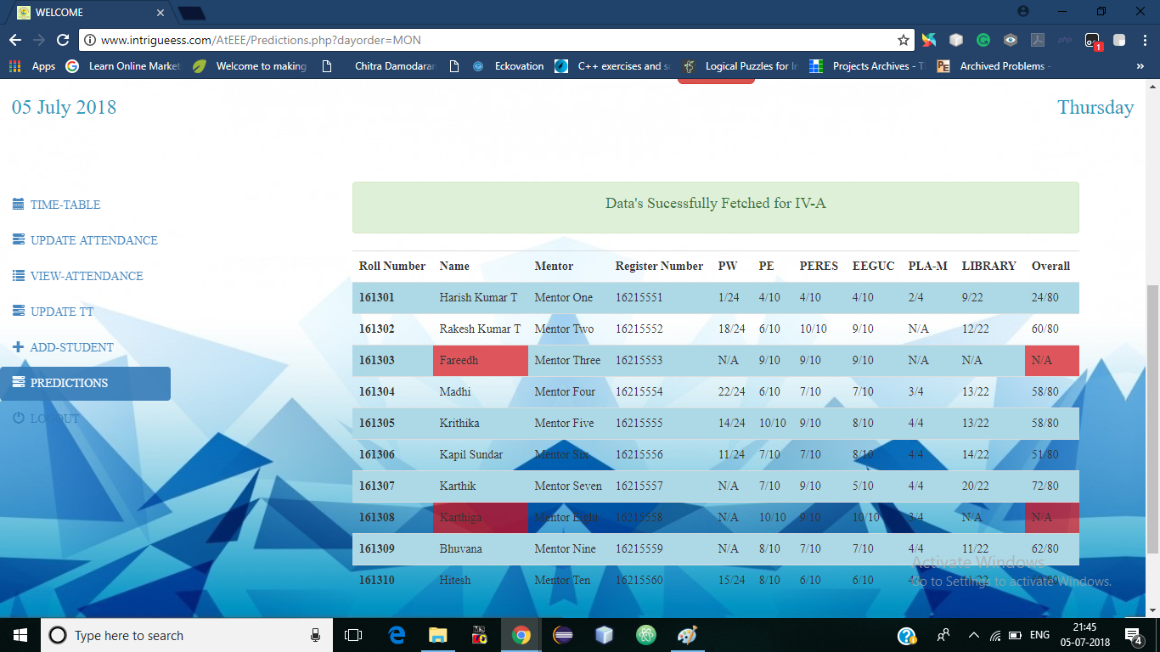If the user enters the Year-Sec with number of Days left for the end of semester (Say 10 days), it will display the number of hours a particular student should attend in order to attain 75% attendance in every subject as well as overall (N/A implies that the student will not be able to get 75% attendance in overall).

*ADMIN*

*FEATURES*

**UPDATE SUBJECTS**

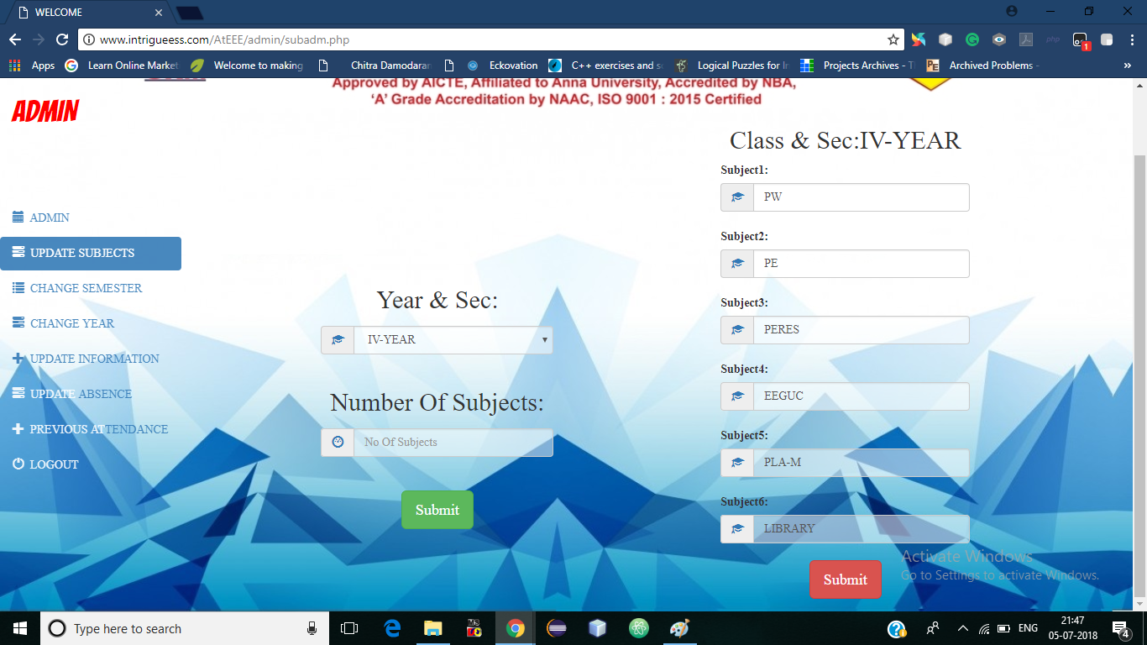In this page, the admin will be able to update/set the number of subjects & their names for the three years. The admin can update the subjects if the regulations for the syllabus are changed with the number of subjects. If the number of Subjects is not mentioned, the current subjects will be displayed.

If the number of subjects is mentioned, the specific fields will be displayed to fill the added subjects.

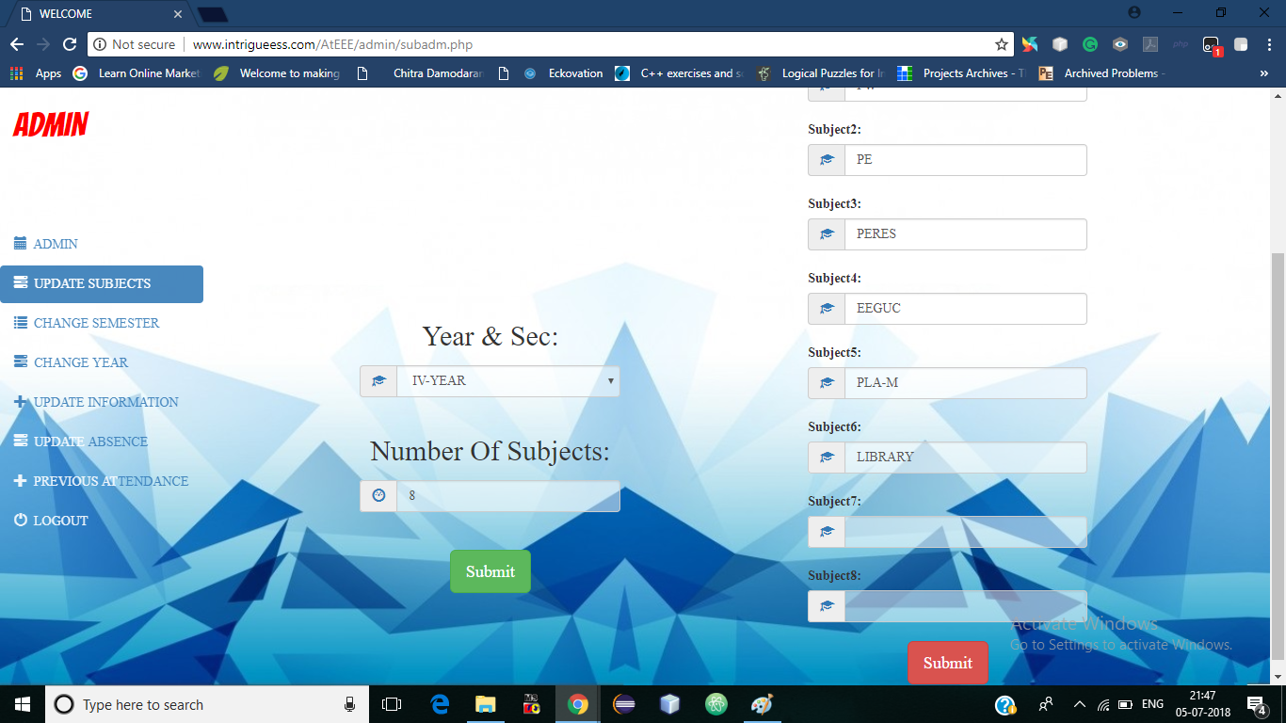

**CHANGE SEMESTER**

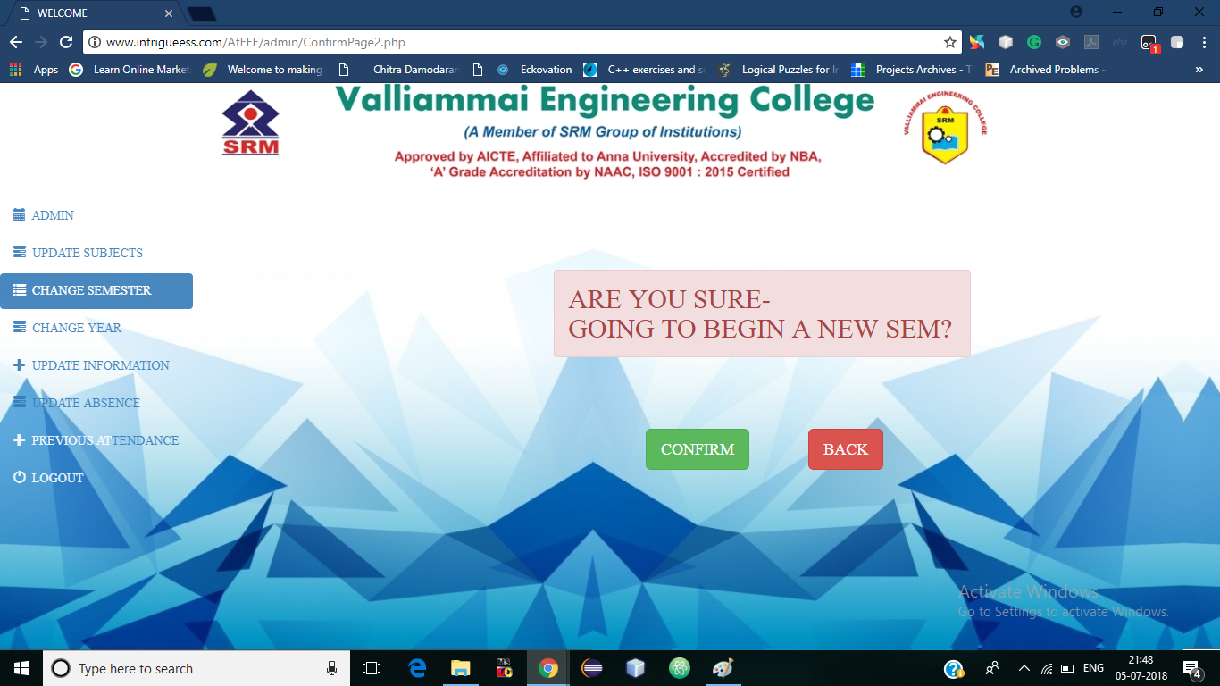In this page the admin should click the confirm button only when we are moving from odd semester to even semester as we have the to retain the student records in their respective Year-Sec in order to reject the inconvenience of re-entering the data & make their current attendance % to zero

*The Overall % will be stored as a separate file which can be viewed later

**CHANGE YEAR**

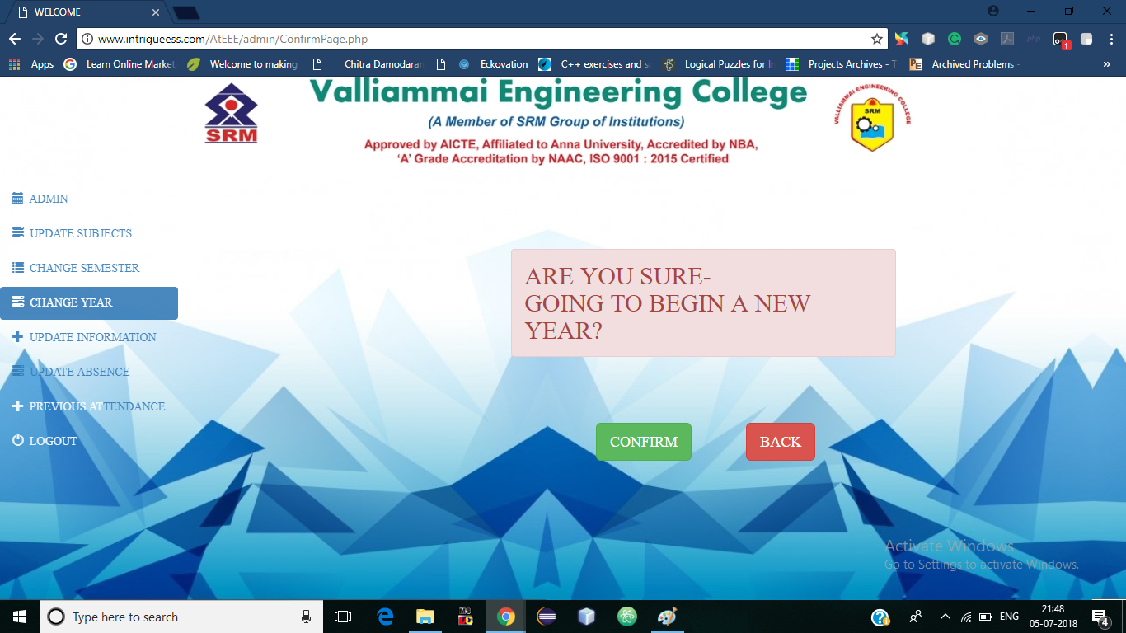In this page the admin should click the confirm button only when we are moving from even semester to odd semester as we have the to change the student records in the next Year-Sec in order to neglect the inconvenience of re-entering the data & make their current attendance % to zero.

*The Overall % will be stored as a separate file which can be viewed later

**UPDATE INFORMATION**

In this page, the admin will have the authority to modify the information entered by the user at the time of adding the new student details. In case when the user enters an incorrect data, this feature can be utilised.

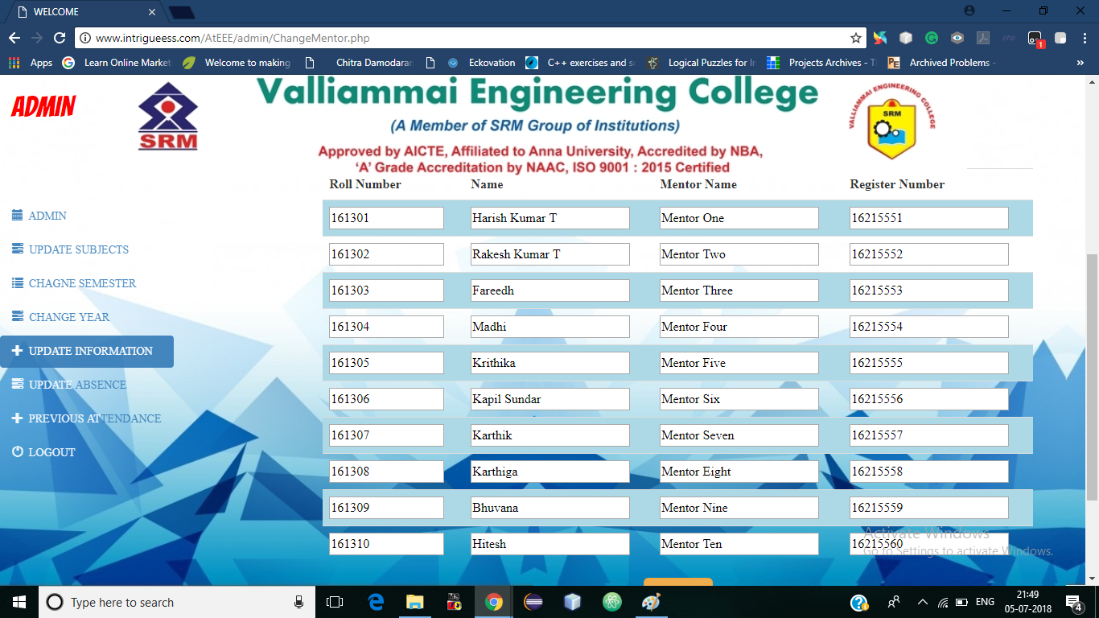

**UPDATE ATTENDANCE**

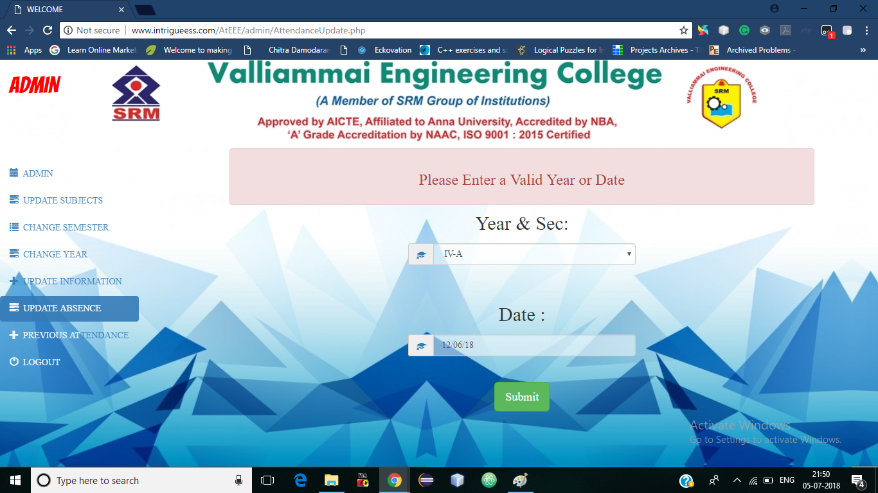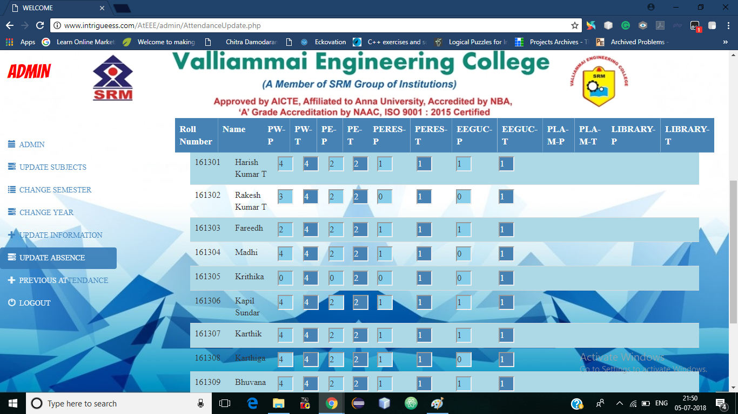In this page, the admin will have the authority to change the number of hours present (cannot modify the total number of hours) on the specific day for a specific student. This feature is used when the user enters the data an incorrect data.

**PREVIOUS ATTENDANCE**

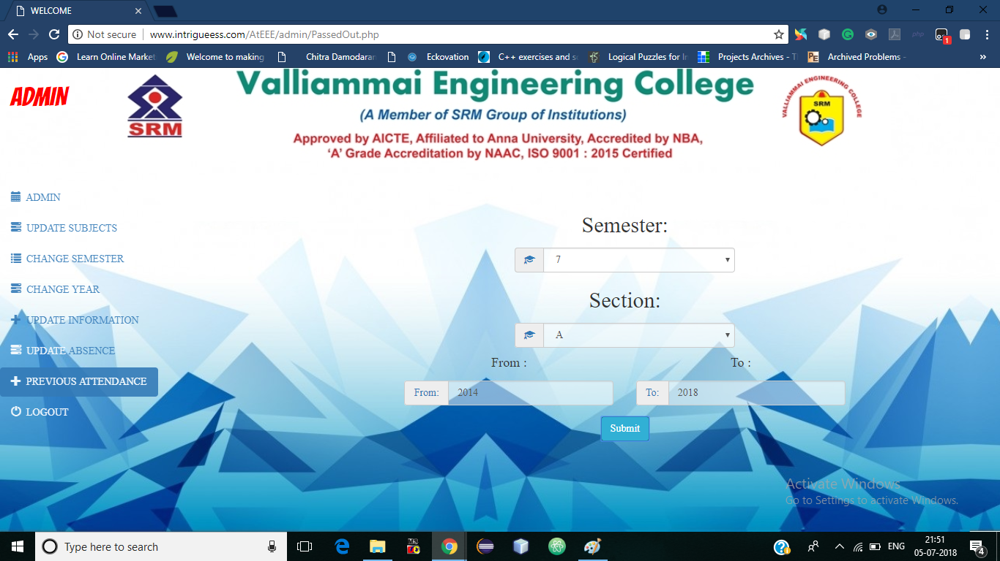In this page, the admin will be able to view the Overall % previously stored data such as when we move from Semester to Semester, the total percentage of every student will be stored which can be viewed by entering the Semester, Section & the batch of the student/class.

